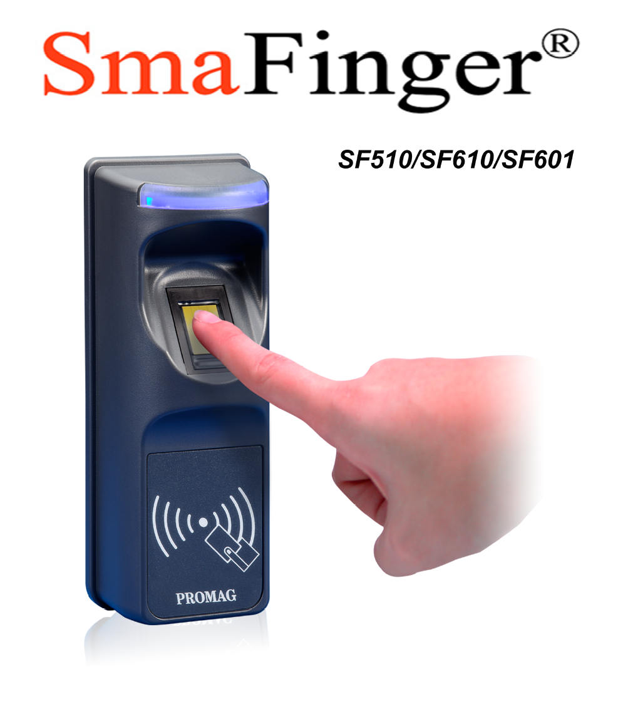
Application:

1. Access Control
2. Time Attendance
3. Guest Registration System
4. Academic Services
5. Info Services

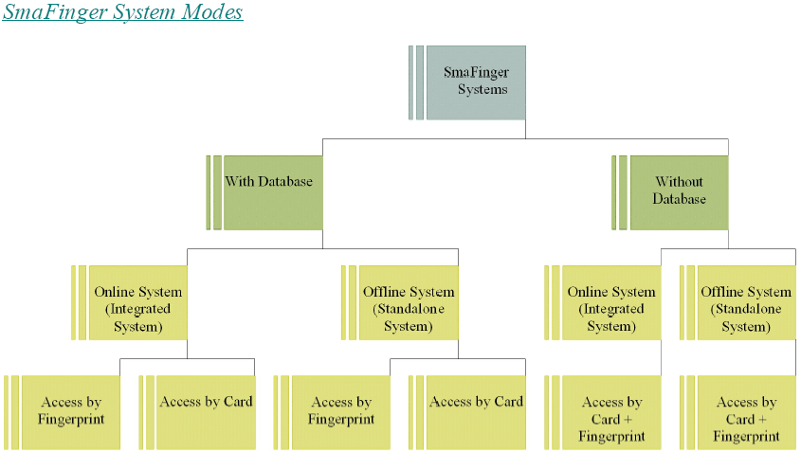

Mode Description
With Database Fingerprint data are stored in reader database for verification.

Without Database Users’ fingerprint are not stored in PC or reader but on User Card for verification.

Integrated System Card issuer, programmer and reader are used with PC. Data transfer to reader can be done online and also offline through a card generated by the system.

Standalone System Only the reader is necessary. Manager Enroll Card and Manager Delete Card
supplied by Giga-Tms along with User Cards are required.

Access by Fingerprint User gains access by scanning fingers at the reader.

Access by Card User gains access by scanning card at the reader.

Access by Fingerprint +
Card User gains access by scanning both card and finger.

Package Contents
Online System
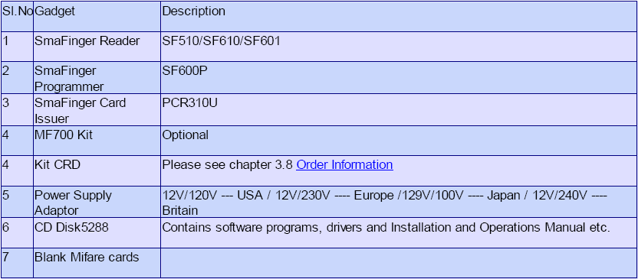

Offline System
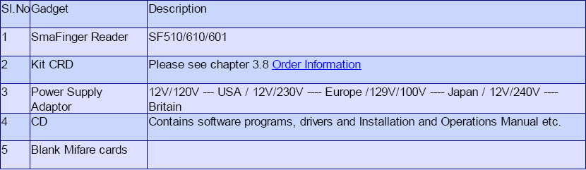

Note:
You will need a host PC with Operating System 98SE/ME/2K/XP/Vista.

Single Reader

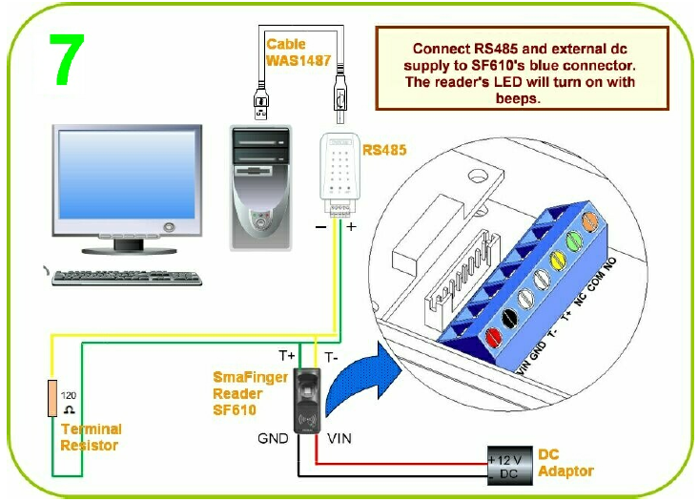
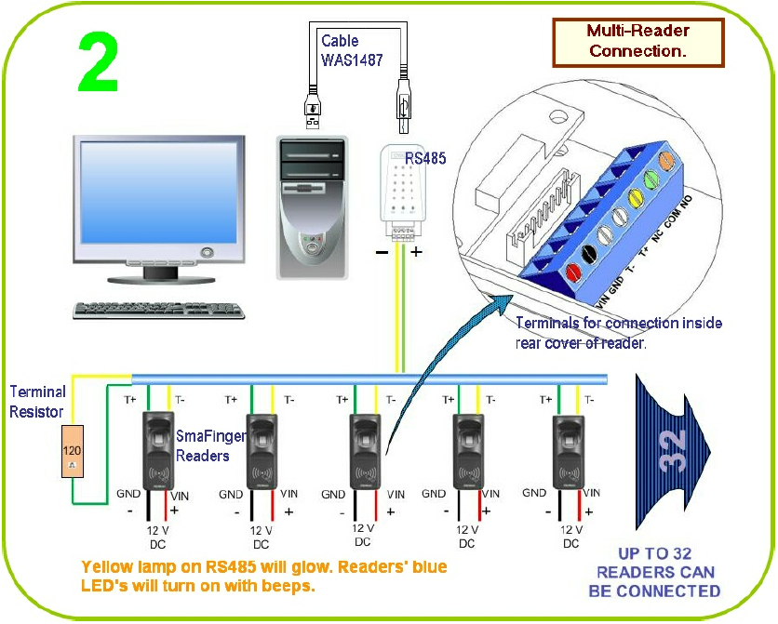

Door Lock Connection

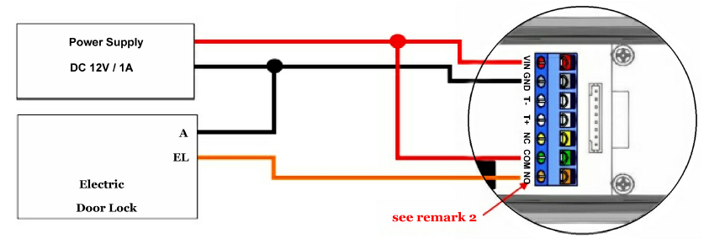

Soft for SmaFinger Systems

